

**Mawlana Bhashani Science and Technology University**

**Lab-Report**

Report No: 04

Course code: ICT-4202

Course title: Wireless and Mobile Communication Lab

Date of Performance: 11.09.2020

Date of Submission: 18.09.2020

**Submitted by Submitted To**

Nazrul Islam

Assistant Professor

Dept. of ICT

MBSTU.

Name:Md Abdullah Al Mamun

ID:IT-15017

4th year 2ndsemester

Session: 2014-15

Dept. of ICT

MBSTU.

**Experiment No: 04**

**Experiment Name: Protocol Analysis with Wireshark**

**Objectives:**

* Capture live packet data from a network interface.
* Display packets with very detailed protocol information.
* Filter packets on many criteria.
* Search for packets on many criteria.
* Colorize packet display based on filters.
* Create various statistics.

**Capturing Packets:**

By clicking Capture menu the process of capturing will be started. It will show the available interfaces list. Then, we need to start Capturing on interface that has IP address

The packet capture will display the details of each packet as they were transmitted over the wireless LAN.

Capturing can be stopped by clicking on Stop the running capture button on the main toolbar.

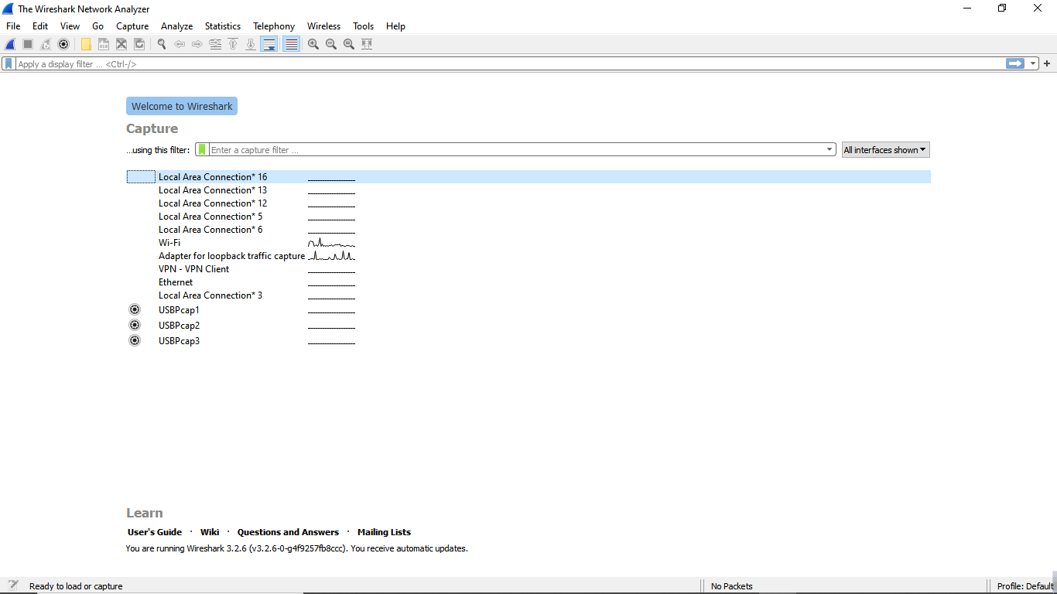

**Figure 01: Wireshark Interface List**

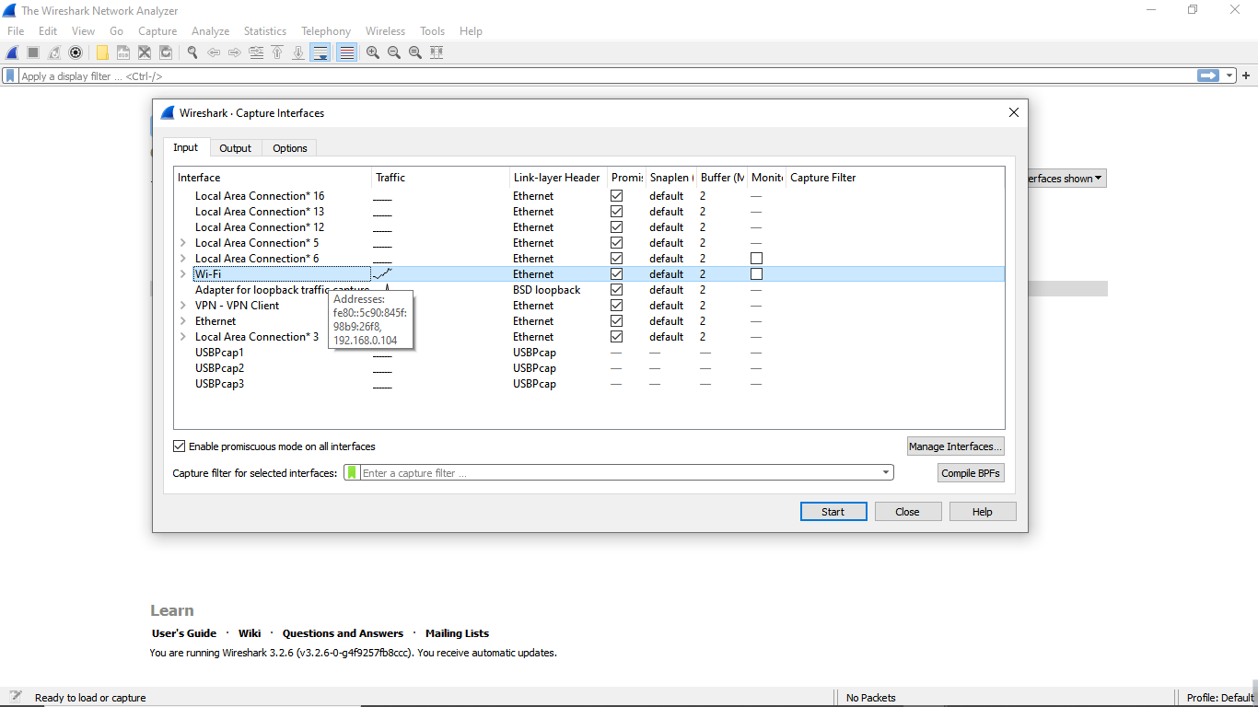

**Figure 02: Start Capturing Interface that has IP address**

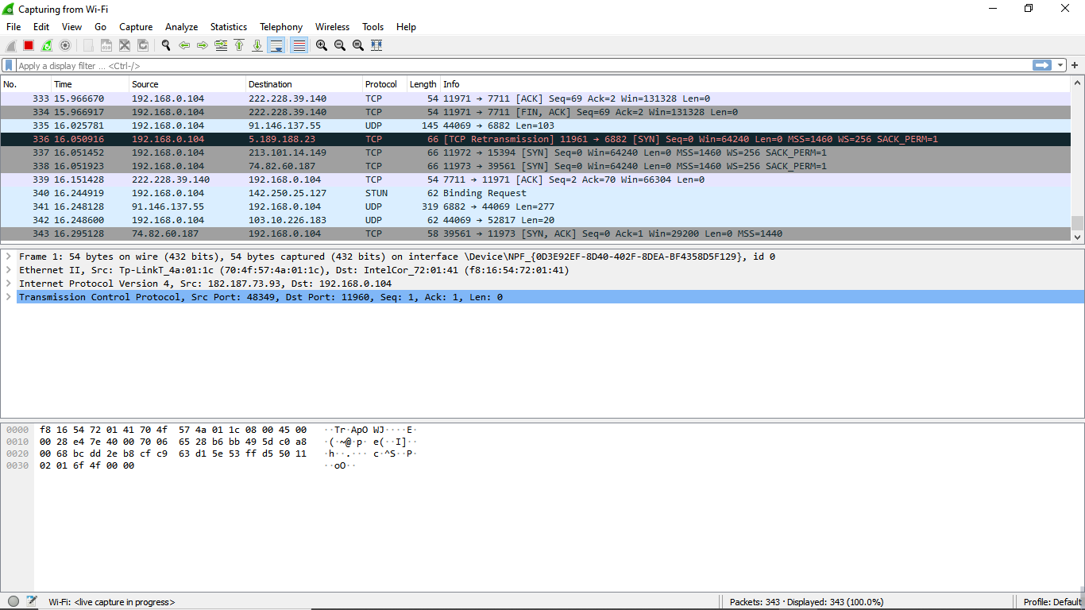

Packet bytes pane

Packet details pane

Packet list pane

**Figure 03: A sample packet capture window**

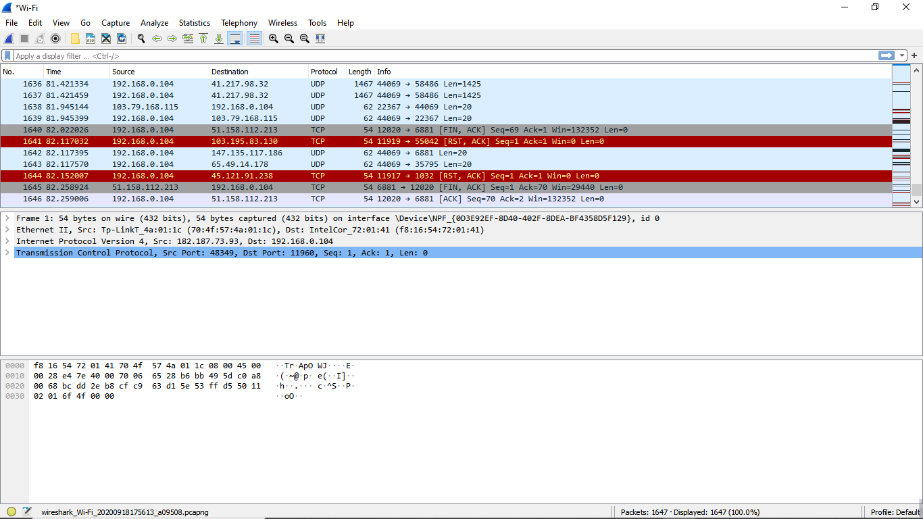

**Figure 04: Stopping Capture**

**Filtering:**

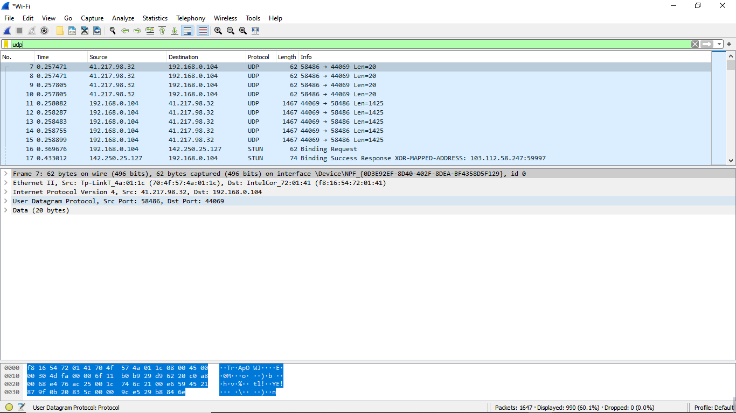

**Figure 05: Filter by Protocol**

A source filter can be applied to restrict the packet view in wireshark to only those packets that

have source IP as mentioned in the filter.

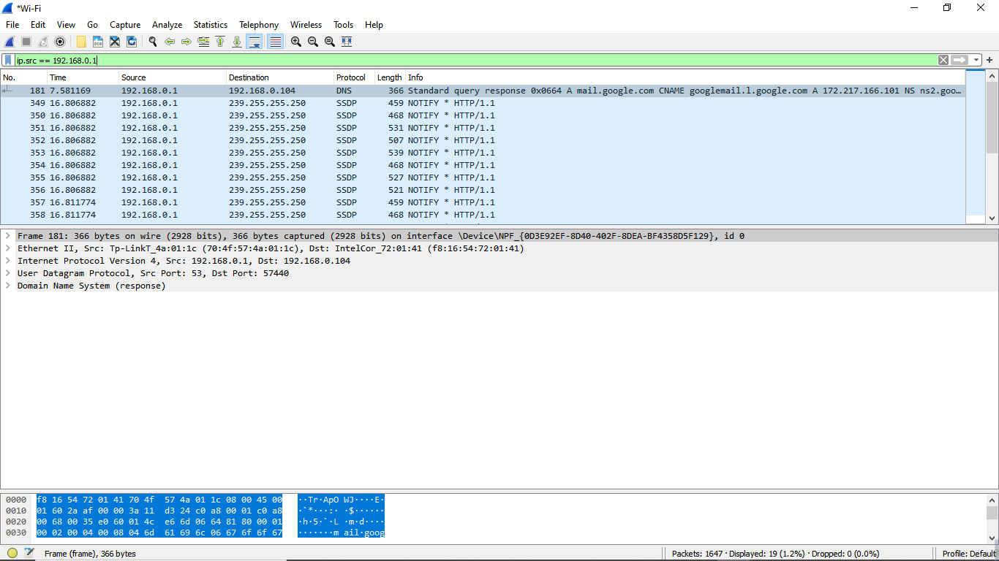

**Figure 06: Source IP filter**

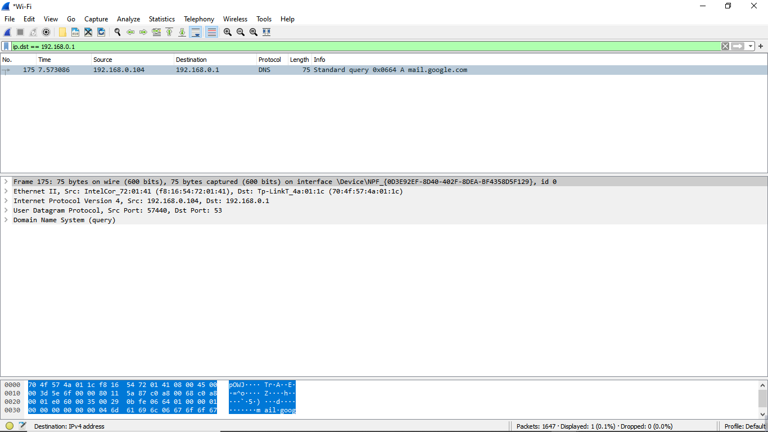

**Figure 07: Destination IP filter**

**• Packets and protocols can be analyzed after capture**

**• Individual fields in protocols can be easily seen**

**• Graphs and flow diagrams can be helpful in analysis**

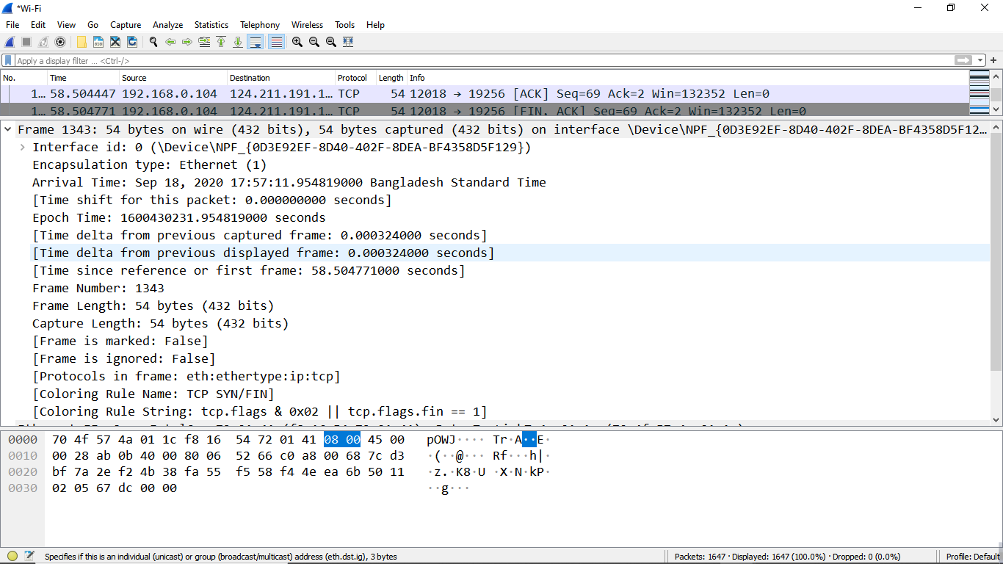

**Figure 08: Packet Details Pane(Frame segment)**

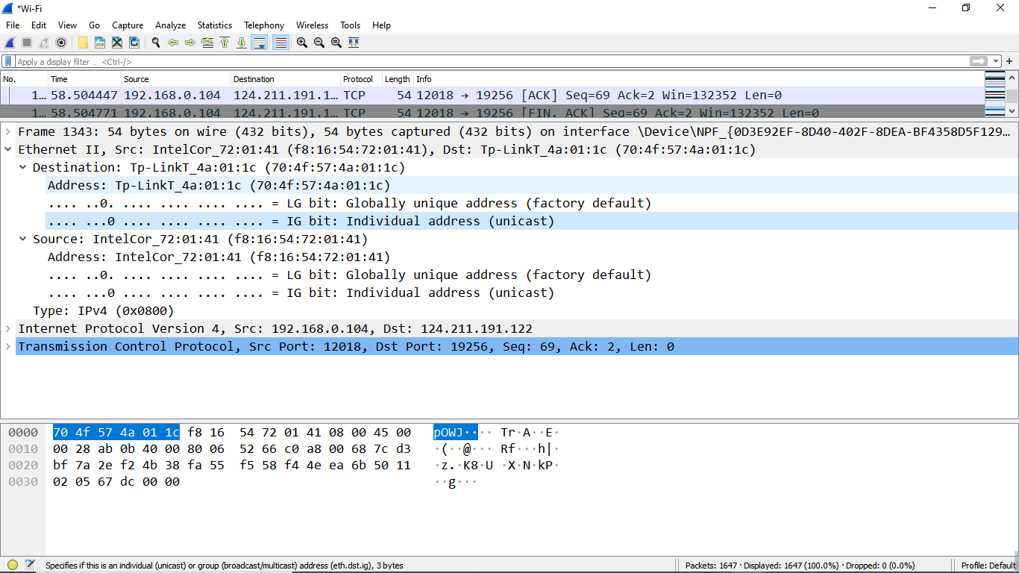

**Figure 09: Packet Details Pane (Ethernet Segment)**

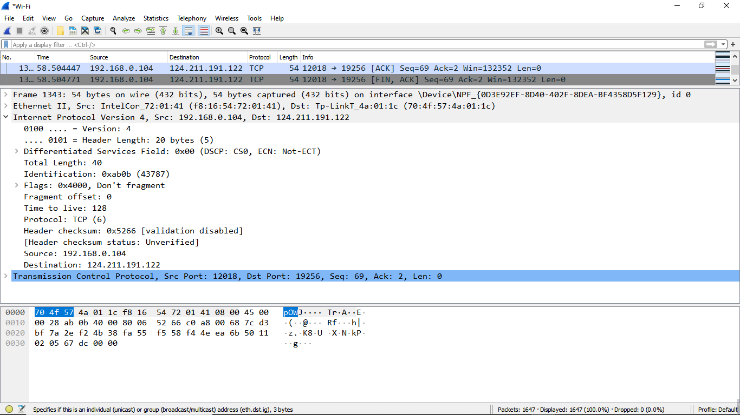

**Figure 10: Packet Details Pane(IP segment)**

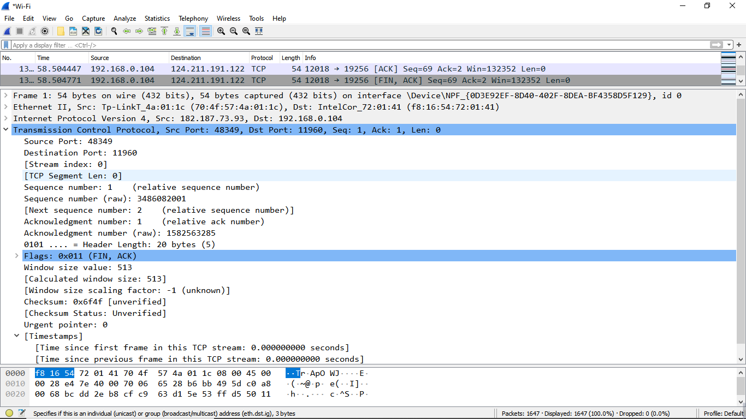

**Figure 11: Packet Details Pane (TCP Segment)**

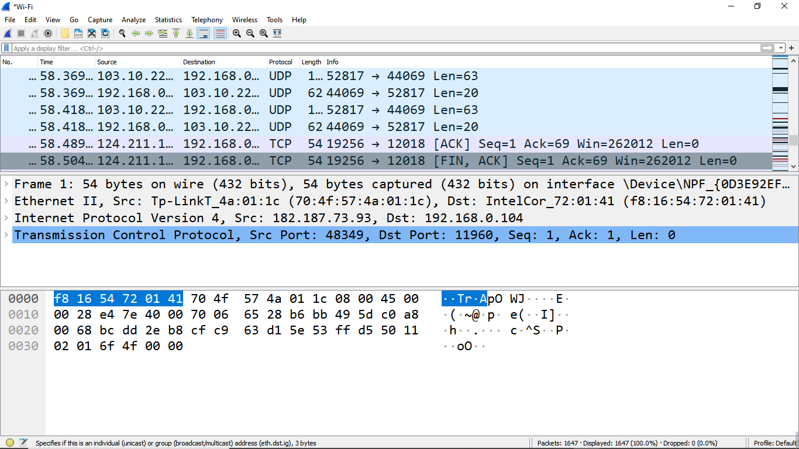

**Figure 12: Packet Byte Pane**

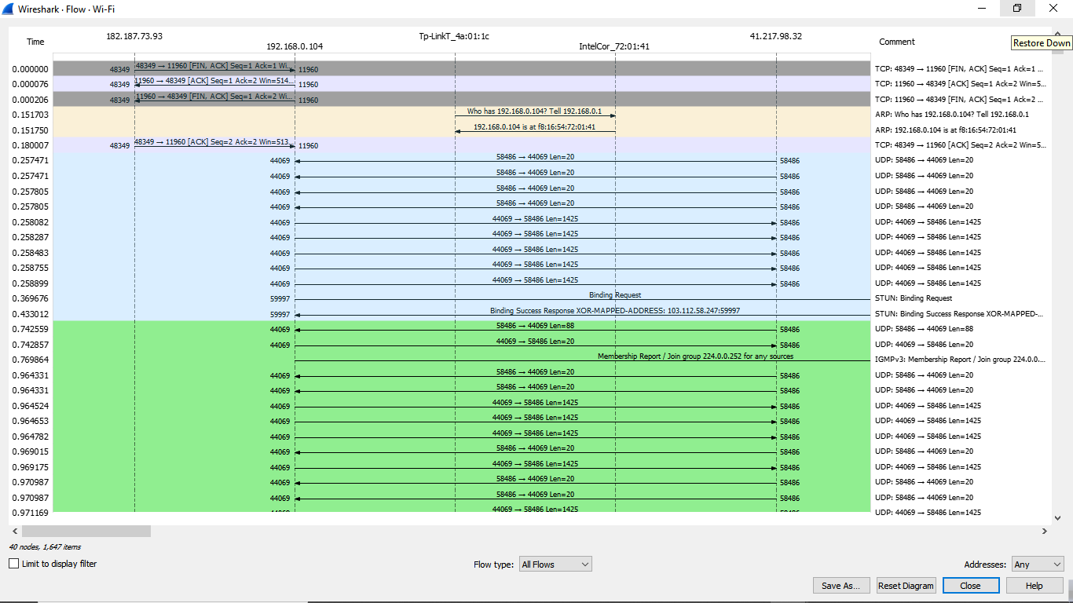

**Figure 13: Statistics- Flow Graph(All Flows)**

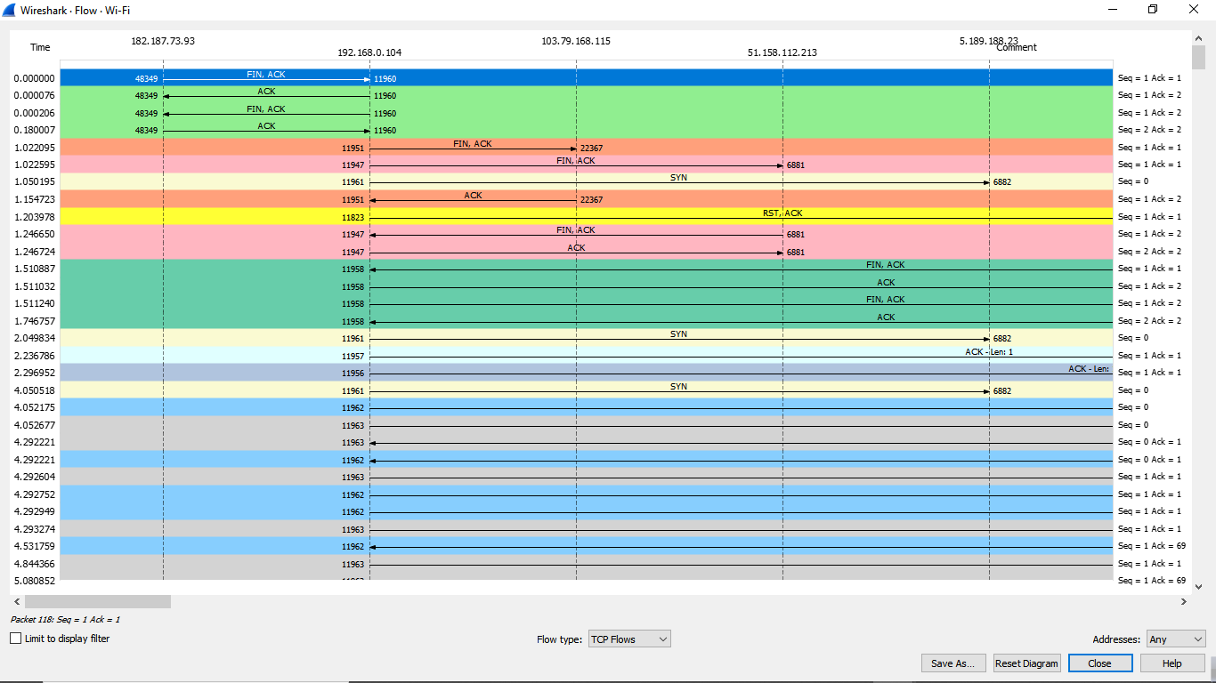

**Figure 13: Statistics- Flow Graph(TCP Flows)**

**Conclusion:**

After downloading and installing Wireshark we can easily Capture live packet data from a network interface using Wireshark. We have applied filter to monitor particular traffic. The TCP Stream Throughput graph have shown us the throughput from one TCP stream, in one direction, based on the selected packet.